**Install Nexus3.2:**

wget <https://sonatype-download.global.ssl.fastly.net/nexus/3/nexus-3.28.1-01-unix.tar.gz>

**reference:**

https://help.sonatype.com/repomanager3/download

**Then follow below link except 2nd step download link:**

<https://acloudxpert.com/install-nexus-repository-manager-in-amazon-linux/>

**docker registry setup in nexus**

**Steps:**

* Create a new Docker (hosted) repository
* Add HTTP port is 8083 (make sure enable/add 8083 port in security group )
* Check "enable Docker V1 API:"
* Blob store is default

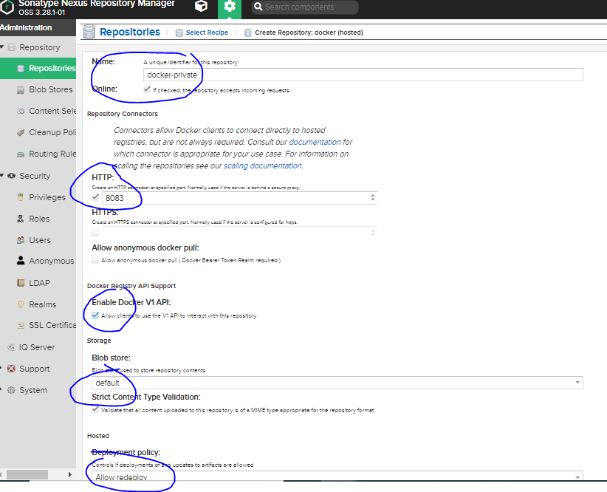

* Make active Docker Bearer Token Realm

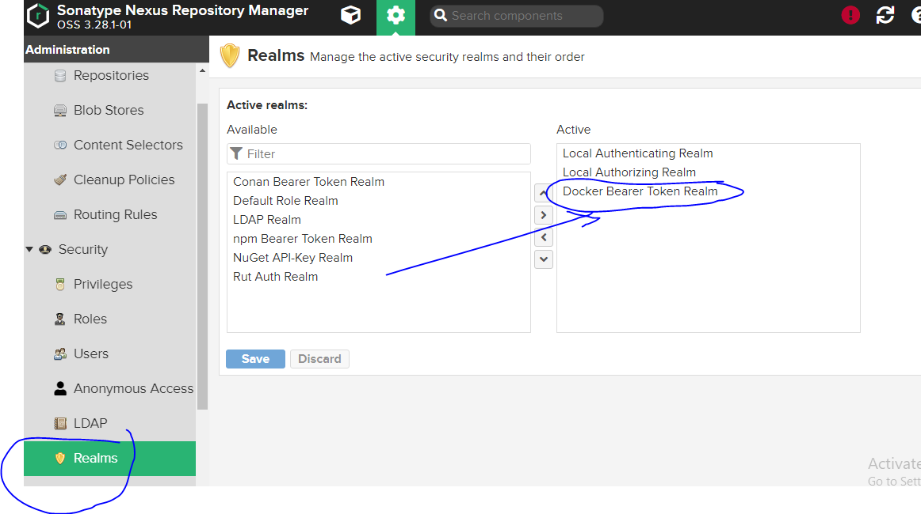

**==>validate:**

In docker server run below command:

curl -X GET <http://13.212.168.95:8081/repository/hcldocker/v2/_catalog> (change ip and repo name)

**Output:**

{"repositories":[]}

**Add IP to daemon.json file like below:**

sudo vim /etc/docker/daemon.json

{

"insecure-registries" : ["13.212.168.95:8083"]

}

**Restart docker service:**

service docker restart

**==> validate**

docker info (it will give repos list which we configured in daemon.json)

**==> Login to docker**

docker login -u admin -p admin123 13.212.168.95:8083

**Pull docker base image from deocker hub:**

docker pull busybox

**tag the image:**

docker tag busybox:latest 13.212.168.95:8083/busybox:latest

**push docker image:**

docker push 13.212.168.95:8083/busybox:latest

==>refrence:

https://www.stefreitag.de/wp/2018/10/03/sonatype-nexus-as-docker-registry-replacement/

https://blog.sonatype.com/using-nexus-3-as-your-repository-part-3-docker-images